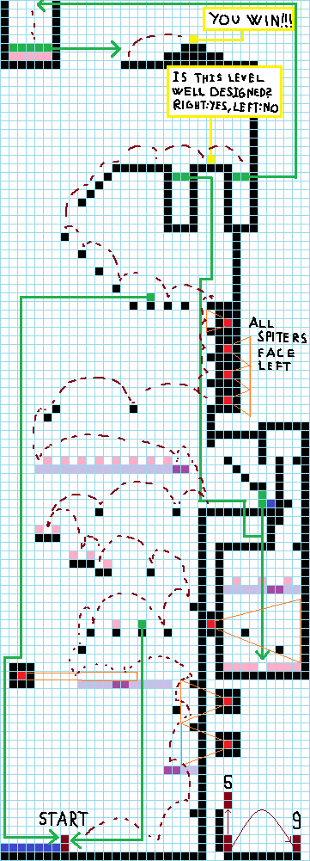Tower of DEATH

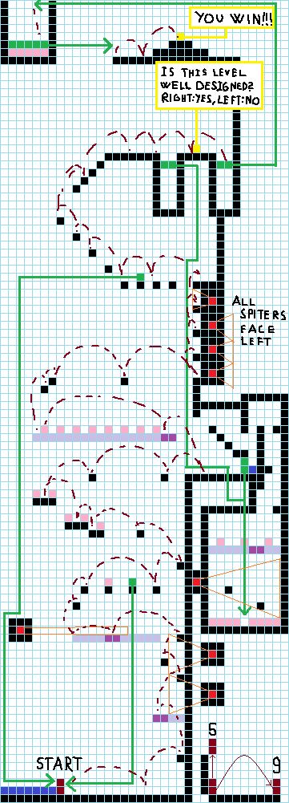

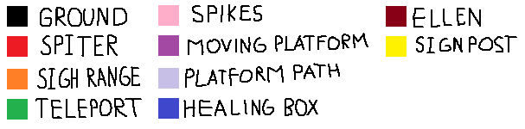

Teleporters should be invisible, or have a very small and easy to miss visual effect.  
Ellen’s HP should be left at the default value (5), as well as spike and spitter damage (1).  
Spitters spits should have small knockabck, enoguh to push you 1 to 2 tiles away. Spikes should have a similar knockback.  
Other than the psychological damage done to the player their wont be any damage from falling